
International Journal of Convergent Technologies and Future Systems (IJCTFS)
Website: https://www.maulikavyanshufoundation.org/IJCTFS/index.php Email: maulikavyanshuijctfs@gmail.com | ISSN No: 3108-1312
Research Today, Future Tomorrow Volume 02 Issue-01 January-February 2026

Security challenges in cloud based application

Abstract –
This paper talks about the main security problems in cloud computing. Cloud services are growing very fast because they make storing and using data easier and cheaper. But the biggest worry for anyone using the cloud is keeping their data safe. Since cloud systems are all online, hackers can try to break in and steal information. As more people use cloud services, the risks also increase. Companies are working hard to improve cloud security, but attackers are also finding new ways to exploit weaknesses. The paper explains different cloud models and services, the risks like virtualization flaws, storage issues, and shared access problems, and challenges such as cyberattacks, insider misuse, lack of standards, insecure APIs, and government intrusion. It concludes that cloud security is not just about technology—it also depends on people and processes. To keep cloud systems safe, organizations need strong policies, transparency, and advanced protection methods.
- Introduction –
Cloud computing is a way of using the internet to access IT resources such as storage, servers, applications, and computing power without having to buy or maintain them yourself. Instead of investing in expensive hardware and software, organizations can simply “rent” what they need from cloud providers and pay only for what they use. This makes cloud computing a flexible, cost-effective, and reliable solution, which is why it has quickly become one of the most important technologies in the IT world.
Different industries use cloud computing in many ways. For example, healthcare companies use it to design personalized treatments, financial services use it for fraud detection and real-time monitoring, and businesses of all sizes rely on it for data backup, disaster recovery, software testing, and customer service. The cloud is not just about applications—it is service-oriented, meaning it provides access to resources whenever needed.
However, with all these benefits comes a major challenge: security and privacy of data. Since cloud systems are based on the internet, they are vulnerable to attacks and misuse. Data stored in the cloud can be accessed by unauthorized users if proper protections are not in place. While cloud providers do have policies and mechanisms to defend against malware and other threats, risks remain—especially when data is shared between organizations. This sharing, while useful, also increases the chance of data being misused.
Because of these risks, protecting information stored in the cloud must be the first priority. The paper focuses on explaining the different models of cloud computing, the risks associated with storing and accessing data online, and the challenges organizations face in keeping their systems secure. It highlights that cloud computing is growing rapidly, but so are the threats, making security research and solutions more important than ever.
Objective:
• To explain what cloud computing is and how different industries use it for tasks like data storage, backup, healthcare, and finance.
• To identify the main risks and threats that come with storing and accessing data in the cloud.
• To discuss the security challenges such as cyberattacks, insider misuse, insecure APIs, lack of transparency, and government intrusion.
• To highlight the importance of protecting data privacy and integrity in cloud environments.
• To review existing protection methods and policies used by cloud service providers.
• To raise awareness about the need for stronger, more advanced security solutions as cloud adoption continues to grow.
• To emphasize that cloud security is not only about technology but also about people and processes working together.
Data analysis
- Data security is a major concern in cloud based application
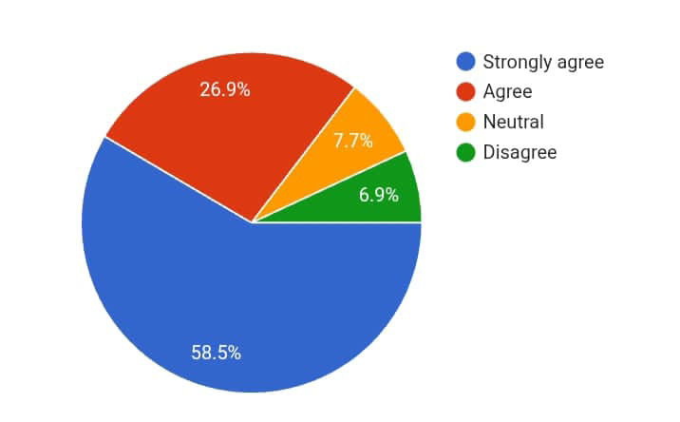

- How would you rate your knowledge of cloud security?

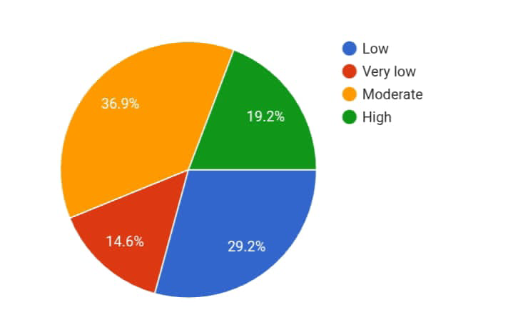

3.Unauthorized access is a significant cloud security challenge.

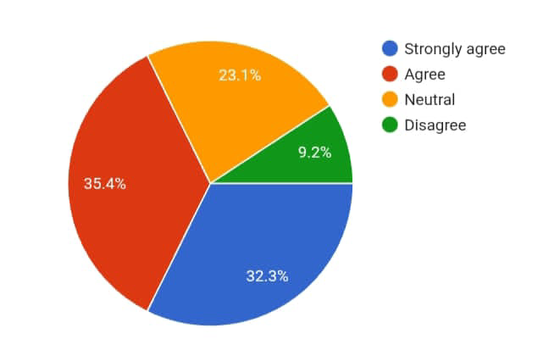

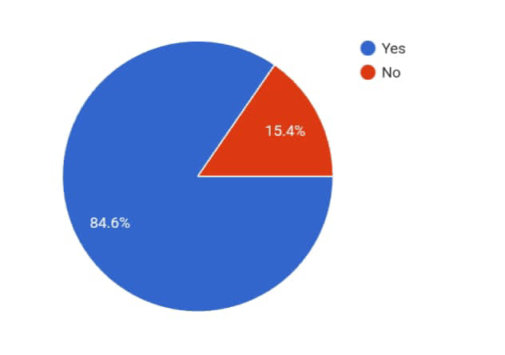
4. Are you familiar with cloud computing concepts?

- Data privacy is a major concern when using cloud based application

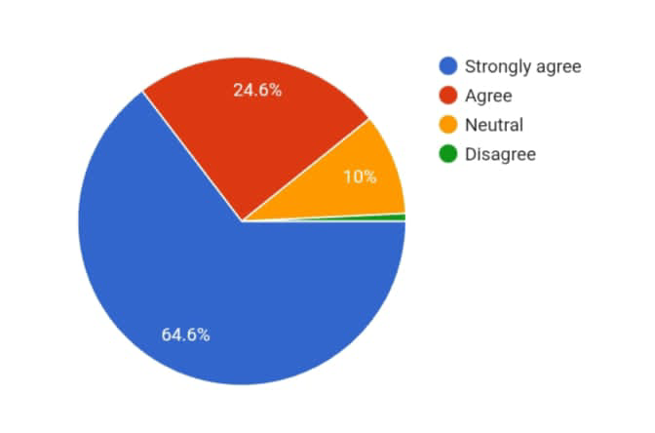

- Do you use cloud based application regularly?

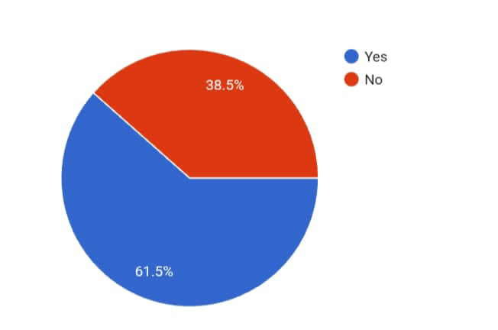

Hypothesis
H1: Data security is a major concern in cloud based application
Sr no. | Smooth functioning | Oi | Ei | Oi-Ei | (Oi-Ei).2 | (Oi-Ei).2/Ei
1. | Strongly agree | 76 | 32.5 | 43.5 | 1892.25 | 58.22
2. | Agree | 35 | 32.5 | 2.5 | 6.25 | 0.19
3. | Neutral | 16 | 32.5 | -22.5 | 506.25 | 15.57
4. | Disagree | 9 | 32.5 | -23.5 | 552.25 | 16.99
 | Total | 130 | - | - | - | 90.97
∑( Oi-Ei)2/Ei = 90.97
Degree of Freedom (df) = 4-1 = 3
3. Calculated x² = 90.97
Tabulated x² = 7.816
Since 90.97 > 7.816
H2: How would you rate your knowledge of cloud security?
Sr no. | Smooth functioning | Oi | Ei | Oi-Ei | (Oi-Ei)2 | (Oi-Ei)2/Ei
1 | Moderate | 48 | 32.5 | 15.5 | 240.25 | 7.35
2 | Low | 38 | 32.5 | 5.5 | 30.25 | 0.93
3 | High | 25 | 32.5 | -7.5 | 56.25 | 1.73
4 | Very low | 19 | 32.5 | -13.5 | 182.25 | 5.60
 | Total | 130 | - | - | - | 15.61
∑( Oi-Ei)2/Ei = 15.67
Degree of Freedom (df) = 4-1 = 3
Calculated x² = 15.67
Tabulated x² = 7.816
Since 15.67 > 7.816
Conclusion
The paper ends by saying that cloud computing is becoming more popular every day, but at the same time, the risks to data security are also growing. To keep information safe, we need to look at cloud security in a complete way. It is not only about technology but also about people and processes working together. Companies must carefully design their systems, decide which parts of the network can talk to each other, and set clear rules for how applications should behave.
Modern cyberattacks are becoming faster and more advanced, so cloud security must also improve to handle these new threats. Strong policies, transparency, and advanced tools are needed to protect data wherever it goes—whether it is with users, devices, or stored in the cloud. The paper highlights that if any one part of security (technology, people, or processes) fails, the whole system can be at risk.
In the end, the author concludes that cloud computing is a very valuable technology for businesses, but its success depends on solving the serious security and privacy challenges. Only by addressing risks like cyberattacks, insider misuse, insecure APIs, and lack of standards can organizations make cloud computing safe and reliable for the future.
Reference
Shen, Z., Tong, Q. (2010): The security of cloud computing system enabled by trusted computing technology. In: 2nd International Conference on Signal Processing Systems (ICSPS 2010), vol. 2, pp. 2–11.

Ishaq Azhar Mohammed (2018): Identity and Access Management for the Internet of Things. International Journal of Emerging Technologies and Innovative Research, Vol. 5, Issue 5, pp. 1299–1303.

Sudhir Allam (2019): Big Data Might Just Cure Cancer – The Research and the Reality. International Journal of Creative Research Thoughts, Vol. 7, Issue 4, pp. 820–825.

Lakshmisri Surya (2019): Machine Learning – Future of Quality Assurance. International Journal of Emerging Technologies and Innovative Research, Vol. 6, Issue 12, pp. 1078–1082.

Tadapaneni, N. R. (2020): Cloud Computing – An Emerging Technology. International Journal of Innovative Science and Research Technology, Vol. 5.

Ishaq Azhar Mohammed (2019): A Systematic Literature Mapping on Secure Identity Management Using Blockchain Technology. International Journal of Innovations in Engineering Research and Technology, Vol. 6, Issue 5, pp. 86–91.

Jamil, D., Zaki, H. (2011): Cloud Computing Security. International Journal of Engineering Science and Technology, Vol. 3, Issue 4, pp. 3478–3483.

